Practical File

# Subject: Design and Analysis of Algorithm

# **CSB 252**

# **Name- Sumanjay**

# Roll- 161210040

CSE 2nd Year



**Department of Computer Science Engineering**

**National Institute of Technology Delhi**

Index

|  |  |  |  |
| --- | --- | --- | --- |
| **S.No** | **Algorithm Name** | **Page No** | **Teacher’s Sign** |
| 1 | Linear Search |  |  |
| 2 | Binary Search |  |  |
| 3 | Insertion Sort |  |  |
| 4 | Quick Sort |  |  |
| 5 | Min Heap |  |  |
| 6 | Breadth First Search |  |  |
| 7 | Depth First Search |  |  |
| 8 | Fractional Knapsack |  |  |
| 9 | 0/1 Knapsack |  |  |
| 10 | Travelling Salesman Problem |  |  |
| 11 | Longest Common Subsequence |  |  |

**Linear Search**

## //Source Code

#include<iostream>

using namespace std;

int LS(int ar[],int size,int val)

{

int i;

for(i=0;i<size;i++){

if(ar[i]==val)

return i;

}

return -1;

}

int main()

{

int a[50],n,i,val,index;

cout<<"No. of elements: ";

cin>>n;

cout<<"Enter elements\n";

for(i=0;i<n;i++)

cin>>a[i];

cout<<"No. you want to search for : ";

cin>>val;

index=LS(a,n,val);

if(index==-1)

cout<<"Not found!!";

else

cout<<val<<" is present at index "<<index+1;

return 0;

}

**Output**

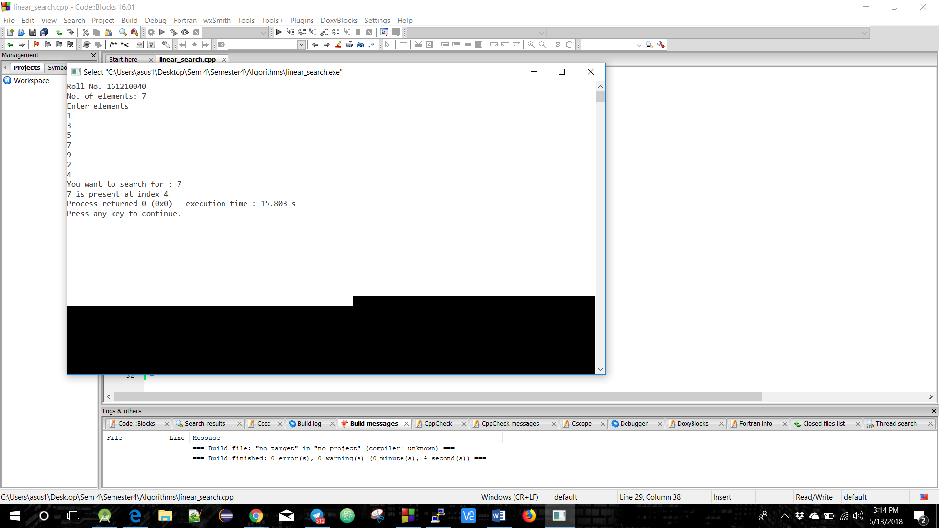

**Binary Search**

# //Source Code

#include<iostream>

using namespace std;

int main() {

int search(int [],int,int);

int n,i,a[100],e,res;

cout<<"Roll Number. 161210040"<<endl;

cout<<"Enter size of the array:"<<endl;

cin>>n;

cout<<"\nEnter Elements of Array in Ascending order\n";

for(i=0;i<n;++i) {

cin>>a[i];

}

cout<<"\nEnter element to search:"; cin>>e;

res=search(a,n,e);

if(res!=-1)

cout<<"\nElement found at position "<<res+1;

else

cout<<"\nElement is not found....!!!";

return 0;

}

int search(int a[],int n,int e)

{

int f,l,m;

f=0;

l=n-1;

while(f<=l) {

m=(f+l)/2;

if(e==a[m])

return(m);

else if (e>a[m])

f=m+1;

else

l=m-1;

}

return -1;

}

## **Output**

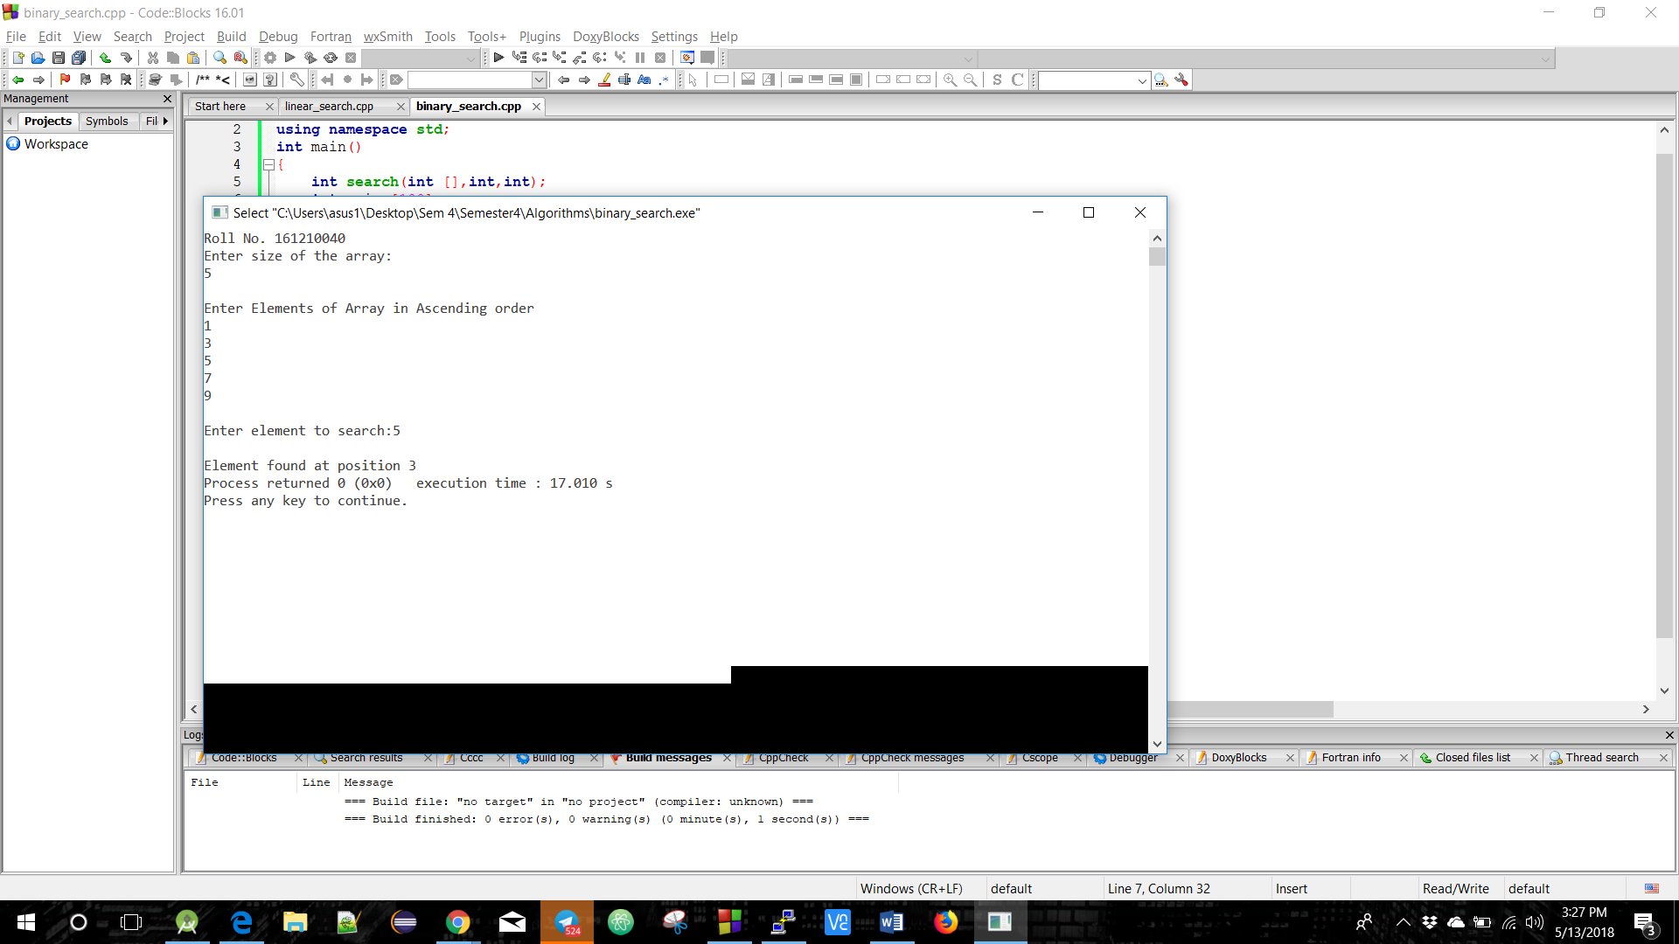

**Insertion Sort**

# //Source Code

#include<iostream>

using namespace std;

int main()

{

int size, arr[50], i, j, temp;

cout<<"Enter Array Size : ";

cin>>size;

cout<<"Enter Array Elements : ";

for(i=0; i<size; i++)

{

cin>>arr[i];

}

cout<<"Sorting array\n";

for(i=1; i<size; i++)

{

temp=arr[i];

j=i-1;

while((temp<arr[j]) && (j>=0))

{

arr[j+1]=arr[j];

j=j-1;

}

arr[j+1]=temp;

}

cout<<"Sorted Array : \n";

for(i=0; i<size; i++)

{

cout<<arr[i]<<" ";

}

return 0;

}

# **Output**

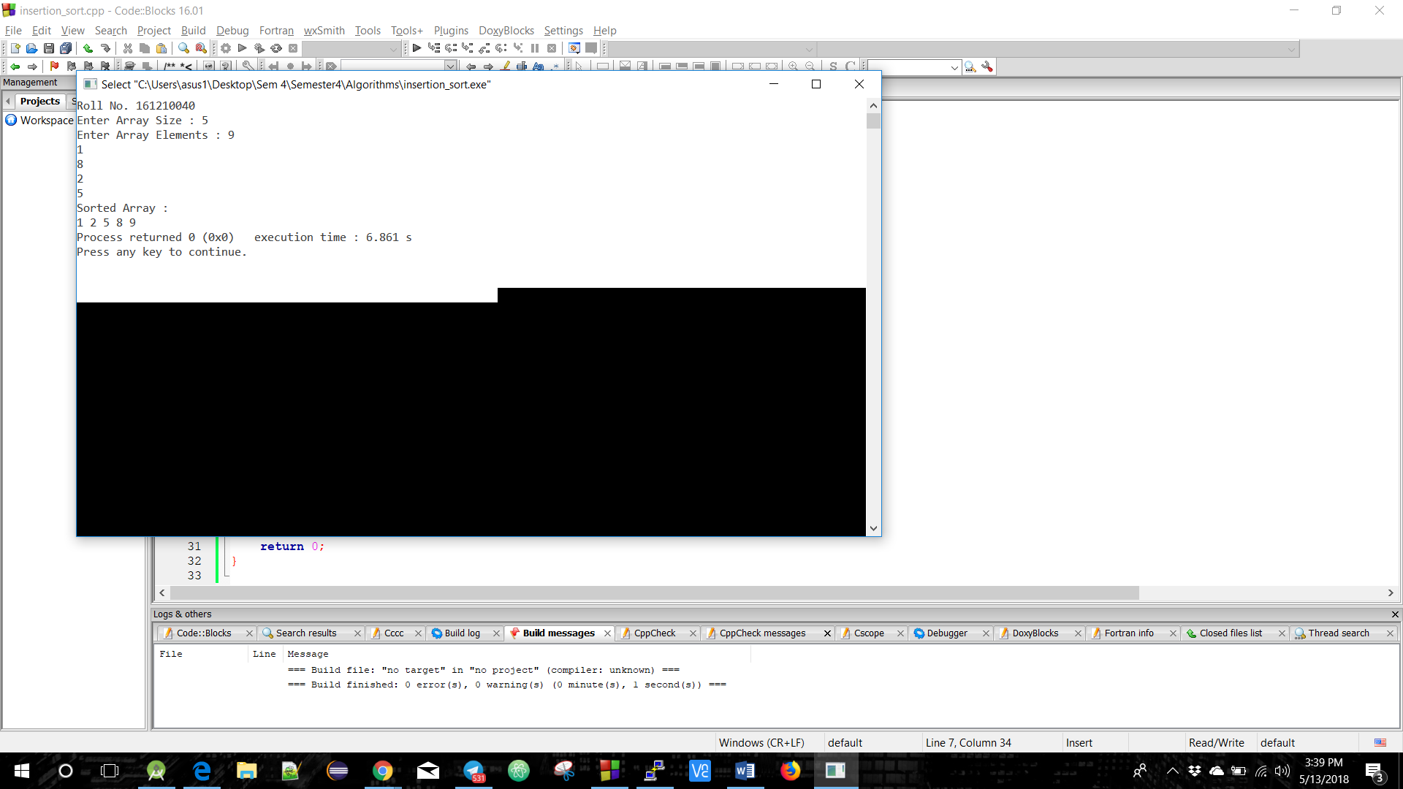

**Quick Sort**

# //Source Code

#include <iostream>

using namespace std;

void quick_sort(int[],int,int);

int partition(int[],int,int);

int main()

{

int a[50],n,i;

cout<<"Roll No. 161210040";

cout<<"\nNo. of elements : ";

cin>>n;

cout<<"\nEnter elements\n";

for(i=0;i<n;i++)

cin>>a[i];

quick_sort(a,0,n-1);

cout<<"\nSorted Array\n";

for(i=0;i<n;i++)

cout<<a[i]<<" ";

return 0;

}

void quick_sort(int a[],int l,int u)

{

int j;

if(l<u)

{

j=partition(a,l,u);

quick_sort(a,l,j-1);

quick_sort(a,j+1,u);

}

}

int partition(int a[],int l,int u)

{

int v,i,j,temp;

v=a[l];

i=l;

j=u+1;

do

{ do

i++;

while(a[i]<v&&i<=u);

do

j--;

while(v<a[j]);

if(i<j)

{

temp=a[i];

a[i]=a[j];

a[j]=temp;

}

}

while(i<j);

a[l]=a[j];

a[j]=v;

return(j);

}

# Output

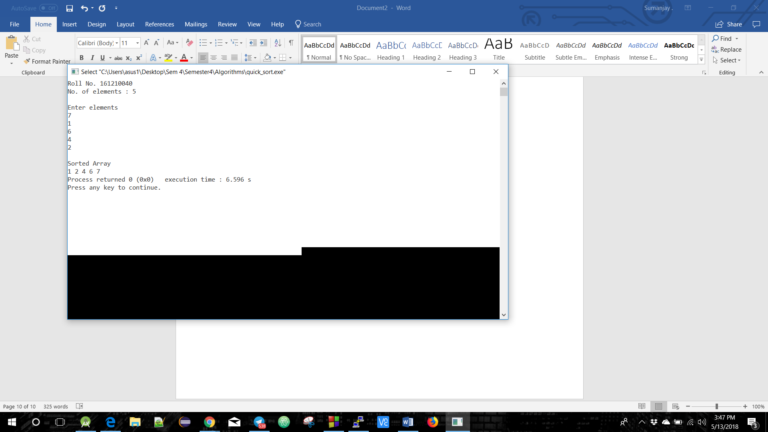

**Min Heap**

# //Source Code

#include <iostream>

using namespace std;

void min_heapify(int *a,int i,int n)

{

int j, temp;

temp = a[i];

j = 2 * i;

while (j <= n)

{

if (j < n && a[j+1] < a[j])

j = j + 1;

if (temp < a[j]) break;

else if (temp >= a[j])

{

a[j/2] = a[j];

j = 2 * j;

}

}

a[j/2] = temp;

return;

}

void build_minheap(int *a, int n)

{

int i;

for(i = n/2; i >= 1; i--)

{

min_heapify(a,i,n);

}

}

int main()

{

int n, i, x;

cout<<"Enter no of elements of Heap:\n";

cin>>n;

int a[20];

for (i = 1; i <= n; i++)

{

cout<<"Enter Number "<<(i)<<endl;

cin>>a[i];

}

build_minheap(a, n);

cout<<"Min Heap\n";

for (i = 1; i <= n; i++)

{

cout<<a[i]<<endl;

}

return 0;

}

# **Output**

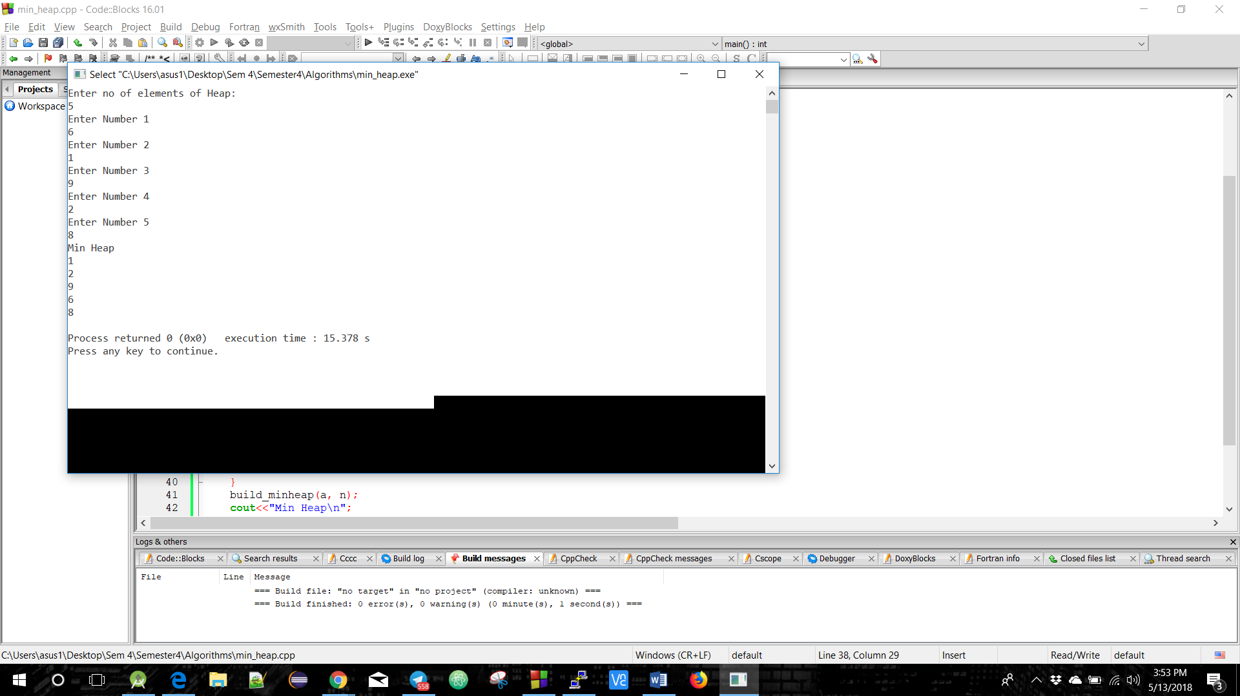

**Breadth First Search**

# //Source Code

#include<iostream>

using namespace std;

int cost[10][10],i,j,k,n,qu[10],front,rare,v,visit[10],visited[10];

int main()

{

int m;

cout<<"Roll No. 161210040\n";

cout <<"Enter no of vertices:";

cin >> n;

cout <<"Enter no of edges:";

cin >> m;

cout <<"\nEdges \n";

for(k=1; k<=m; k++)

{

cin >>i>>j;

cost[i][j]=1;

}

cout <<"Enter initial vertex to start traversal:";

cin >>v;

cout <<"Visited vertices:";

cout <<v<<" ";

visited[v]=1;

k=1;

while(k<n)

{

for(j=1; j<=n; j++)

if(cost[v][j]!=0 && visited[j]!=1 && visit[j]!=1)

{

visit[j]=1;

qu[rare++]=j;

}

v=qu[front++];

cout<<v <<" ";

k++;

visit[v]=0;

visited[v]=1;

}

return 0;

}

# **Output**

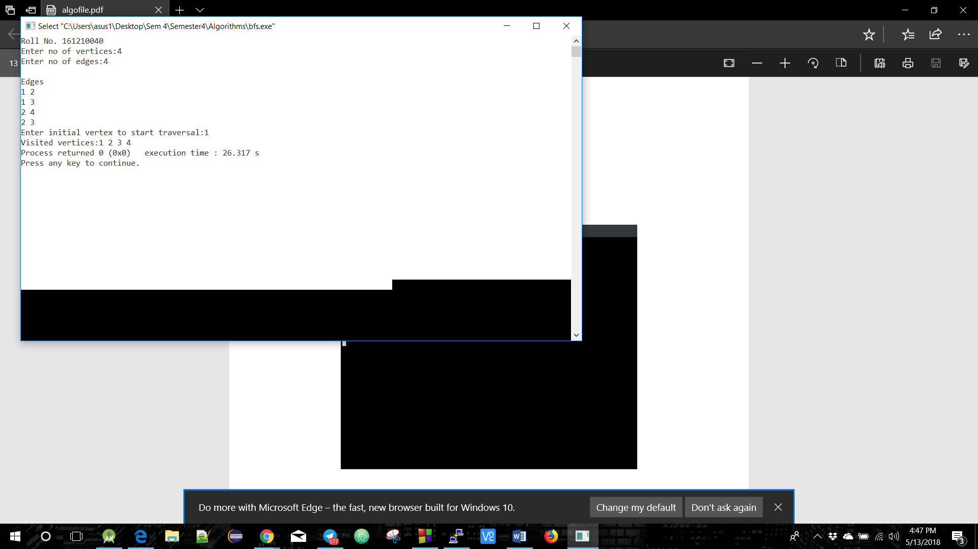

**Depth First Search**

# //Source Code

#include<iostream>

using namespace std;

int cost[10][10],i,j,k,n,stk[10],top,v,visit[10],visited[10];

int main()

{

int m;

cout<<"Roll Number 161210040\n";

cout <<"Enter No. of Vertices";

cin >> n;

cout <<"Enter No. of Edges";

cin >> m;

cout <<"\nEdges: \n";

for(k=1; k<=m; k++)

{

cin >>i>>j;

cost[i][j]=1;

}

cout <<"Enter Initial Vertex";

cin >>v;

cout <<"Visited vertices are in the order: "<<endl;

cout << v <<" ";

visited[v]=1;

k=1;

while(k<n)

{

for(j=n; j>=1; j--) if(cost[v][j]!=0 && visited[j]!=1 && visit[j]!=1)

{

visit[j]=1;

stk[top]=j;

top++;

}

v=stk[--top];

cout<<v << " ";

k++;

visit[v]=0;

visited[v]=1;

}

return 0;

}

# Output

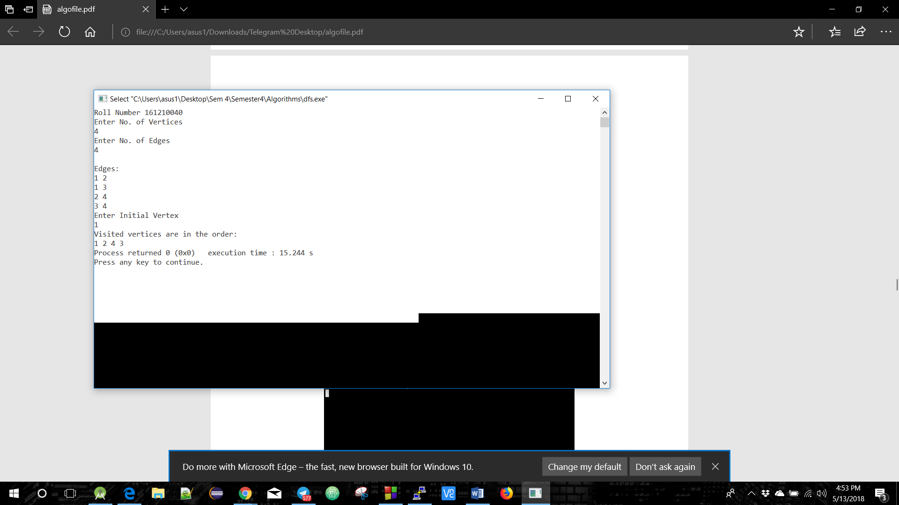

**Fractional Knapsack**

# //Source Code

#include<iostream>

using namespace std;

int max(int a, int b)

{

return (a > b)? a : b;

}

int knapSack(int W, int wt[], int val[], int n)

{

if (n == 0 || W == 0)

return 0;

else if (wt[n-1] > W)

return knapSack(W, wt, val, n-1);

else

return max( val[n-1] + knapSack(W-wt[n-1], wt, val, n-1),knapSack(W, wt, val, n-1));

}

int main()

{

int W;

int val[3],wt[3];

cout<<"Roll Number 161210040\n";

cout<<"Enter Maximum allowed weight: \n";

cin>>W;

cout<<"Enter the value of items\n";

for (int i=0; i<3; i++)

{

cin>>val[i];

}

cout<<"Enter the weight of items\n";

for (int i=0; i<3; i++)

{

cin>>wt[i];

}

int n = sizeof(val)/sizeof(val[0]);

cout<< "Maximum Profit: " <<knapSack(W, wt, val, n);

}

# **Output**

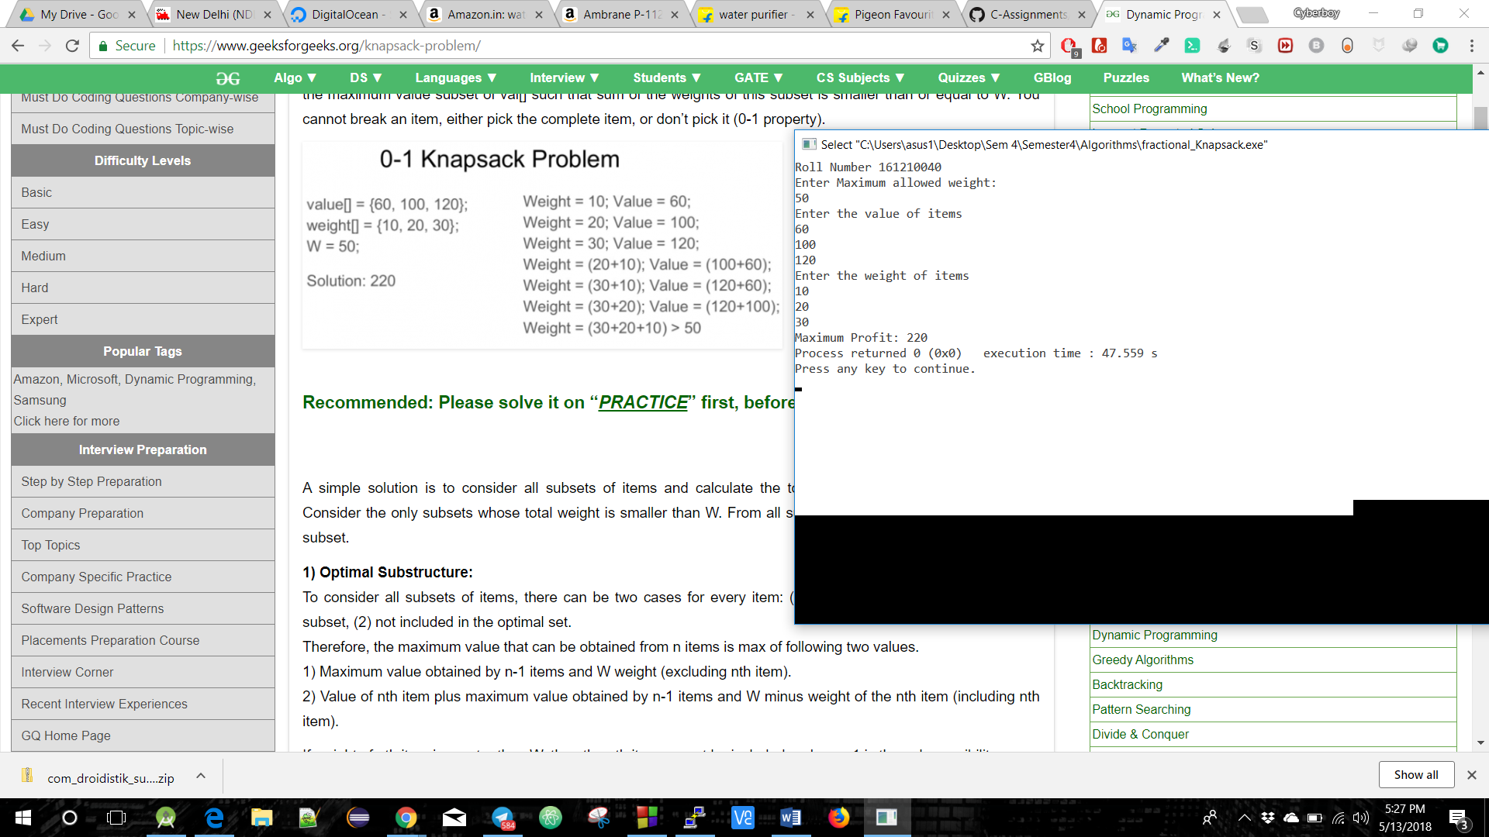

**0/1 Knapsack**

# //Source Code

#include<iostream>

using namespace std;

int max(int a, int b)

{

return (a > b)? a : b;

}

int knapSack(int W, int wt[], int val[], int n)

{

int i, w;

int K[n+1][W+1];

for (i = 0; i <= n; i++)

{

for (w = 0; w <= W; w++)

{

if (i==0 || w==0)

K[i][w] = 0;

else if (wt[i-1] <= w)

K[i][w] = max(val[i-1] + K[i-1][w-wt[i-1]], K[i-1][w]);

else

K[i][w] = K[i-1][w];

}

}

return K[n][W];

}

int main()

{

cout<<"Roll Number 161210040\n";

int i, n, val[20], wt[20], W;

cout<<"Enter number of items:"<<endl;

cin>>n;

cout<<"Enter value and weight of items:\n";

for(i = 0; i < n; ++i)

{

cin>>val[i]>>wt[i];

}

cout<<"Enter Max Allowed Wt:"<<endl;

cin>>W;

cout<<"Maximum profit is:"<<endl;

cout<< knapSack(W, wt, val, n);

return 0;

}

# **Output**

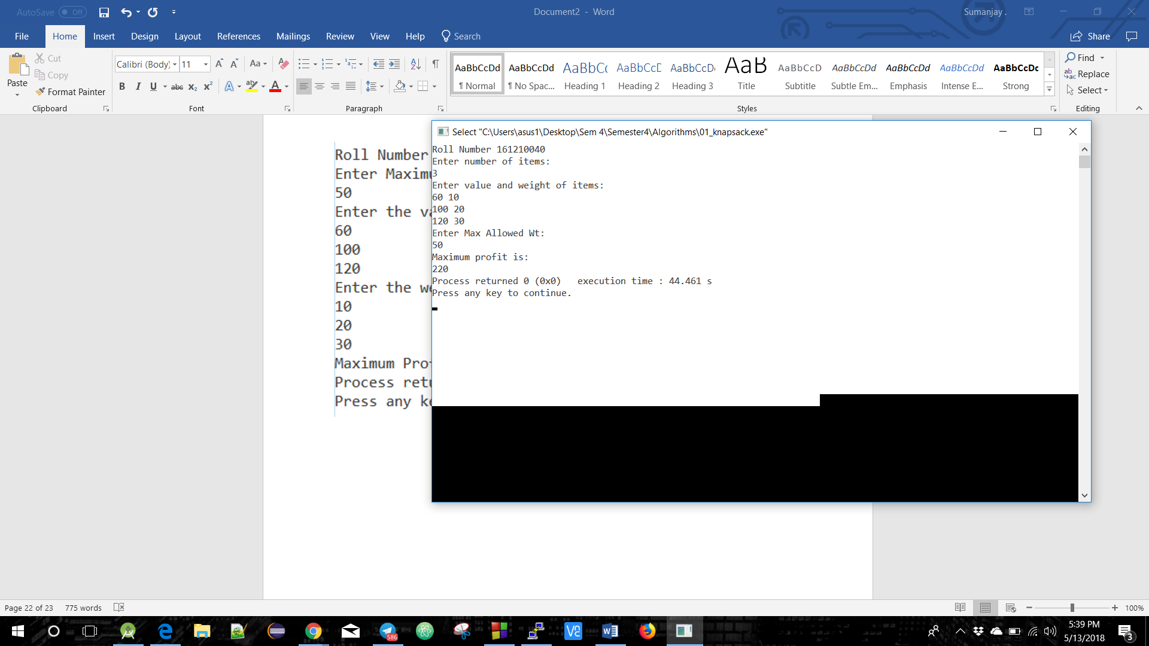

**Travelling Salesman Problem**

# //Source Code

#include<stdio.h>

int a[10][10],visited[10],n,cost=0;

void get()

{

int i,j;

printf("Enter No. of Cities: ");

scanf("%d",&n);

printf("\nEnter Cost Matrix\n");

for(i=0;i < n;i++)

{

printf("\nEnter Elements of Row # : %d\n",i+1);

for( j=0;j < n;j++)

scanf("%d",&a[i][j]);

visited[i]=0;

}

printf("\n\nThe cost list is:\n\n");

for( i=0;i < n;i++)

{

printf("\n\n");

for(j=0;j < n;j++)

printf("\t%d",a[i][j]);

}

}

int least(int c)

{

int i,nc=999;

int min=999,kmin;

for(i=0;i < n;i++)

{

if((a[c][i]!=0)&&(visited[i]==0))

if(a[c][i] < min)

{

min=a[i][0]+a[c][i];

kmin=a[c][i];

nc=i;

}

}

if(min!=999)

cost+=kmin;

return nc;

}

void mincost(int city)

{

int i,ncity;

visited[city]=1;

printf("%d --> ",city+1);

ncity=least(city);

if(ncity==999)

{

ncity=0;

printf("%d",ncity+1);

cost+=a[city][ncity];

return;

}

mincost(ncity);

}

void put()

{

printf("\n\nMinimum cost:\n\n");

printf("\n");

printf("%d",cost);

}

int main()

{

get();

printf("\n\nThe Path is:\n\n");

mincost(0);

put();

return 0;

}

# **Output**

# 

**Longest Common Subsequence**

# //Source Code

#include <iostream>

#include <string.h>

using namespace std;

void lcs( char *X, char *Y, int m, int n )

{

int L[m+1][n+1];

for (int i=0; i<=m; i++)

{

for (int j=0; j<=n; j++)

{

if (i == 0 || j == 0)

L[i][j] = 0;

else if (X[i-1] == Y[j-1])

L[i][j] = L[i-1][j-1] + 1;

else

L[i][j] = max(L[i-1][j], L[i][j-1]);

}

}

int index = L[m][n];

char lcs[index+1];

lcs[index] = ' ';

int i = m, j = n;

while (i > 0 && j > 0) {

if (X[i-1] == Y[j-1])

{

lcs[index-1] = X[i-1];

i--; j--; index--;

}

else if (L[i-1][j] > L[i][j-1])

i--;

else

j--;

}

cout << "\nLongest Common Subsequence of " << X << " and " << Y << " is " << lcs;

}

int main()

{ char x[20],y[20];

int m,n;

cout<<"Roll No. 161210040\n";

cout<<"Enter 1st sequence : ";

cin>>x;

cout<<"\nEnter 2nd sequence : ";

cin>>y;

m=strlen(x);

n=strlen(y);

lcs(x,y,m,n);

return 0;

}

# **Output**

